Are you sweet enough for lifesavers?

[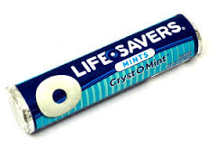](http://www.google.co.uk/url?sa=i&rct=j&q=lifesavers+sweets&source=images&cd=&cad=rja&uact=8&docid=kWIzwWspPz33tM&tbnid=DSp4JGAM0PDE8M:&ved=0CAUQjRw&url=http://www.usafoodstore.co.uk/life-savers-5-flavours-american-candy-1-14oz-32g-lifesavers/&ei=BHKhU-DZFJKe0wW66IF4&bvm=bv.69137298,d.d2k&psig=AFQjCNFHQ0N5fV-AcnWBiLb4Nzd3gto8dg&ust=1403175785227701)

With delicious real fruit pieces in every bowl

[](http://www.google.co.uk/url?sa=i&rct=j&q=oat+so+simple&source=images&cd=&cad=rja&uact=8&docid=tf53pphqQ_kYyM&tbnid=46UkbN06GToCyM:&ved=0CAUQjRw&url=http://www.quaker.co.uk/products/oat-so-simple-pots&ei=WlGgU4TeF-uV0QXrm4DYDQ&bvm=bv.68911936,d.ZWU&psig=AFQjCNHKRKiMAyH7sfoKDLLoMllfFOimWw&ust=1403101900827802)

You either love it or hate it.

[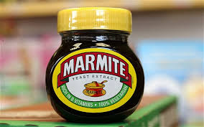](http://www.google.co.uk/url?sa=i&rct=j&q=marmite&source=images&cd=&cad=rja&uact=8&docid=36BdHaNkJzEH6M&tbnid=SCpzFo4ffYfJpM:&ved=0CAUQjRw&url=http://www.telegraph.co.uk/news/uknews/road-and-rail-transport/8922425/Marmite-soars-up-Twitter-after-20-tonne-spillage.html&ei=pFGgU7XaD8jY0QWC14GgBQ&bvm=bv.68911936,d.d2k&psig=AFQjCNHxrrFoFlAFJeDpsGFhBEu5LpxC_g&ust=1403101983810902)

Smooth milk cocoa now sourced from rainforest alliance certified forest

[](http://www.google.co.uk/url?sa=i&rct=j&q=galaxy+chocolate&source=images&cd=&cad=rja&uact=8&docid=br2_50TDnKUIPM&tbnid=3_lkU1aiPsbSzM:&ved=0CAUQjRw&url=https://www.judithgossflorists.co.uk/galaxy-milk-chocolate-family-share-bar-(390g-bar)-codejgfgc01200gc-local-delivery-only_c154_1664.htm&ei=K1KgU_nAItLJ0AXewoCYCA&bvm=bv.68911936,d.d2k&psig=AFQjCNGOqHC-TkJk8SsITh2fSX_liMreIA&ust=1403102027643080)



Marvellous mighty monster truck

R U UP 4 IT? [](http://www.google.co.uk/url?sa=i&rct=j&q=vodafone+mobile+phone&source=images&cd=&cad=rja&uact=8&docid=J6vCPaCS_Qi5DM&tbnid=k_CxfHmZCkdQUM:&ved=0CAUQjRw&url=http://www.dialaphone.co.uk/blog/2009/12/21/vodafone-confirm-iphone-release-and-tariffs/&ei=IlGgU6GJCeWY0AWxr4D4Dg&bvm=bv.68911936,d.ZWU&psig=AFQjCNHAVcRmyPxilTZL2vdzAasitd6oxQ&ust=1403101840357063)

[](http://www.google.co.uk/url?sa=i&rct=j&q=cheryl+cole+elvive&source=images&cd=&cad=rja&uact=8&docid=2YLRBsXVlpxazM&tbnid=jsSt_1wwtB_KFM:&ved=0CAUQjRw&url=http://cheryl-online.net/category/news-stories/page/6/&ei=z1CgU-yaMYWs0QWT6YGgBg&bvm=bv.68911936,d.d2k&psig=AFQjCNFYnS_ppEAxHMsn5JTDl8x3IVuLrA&ust=1403101770579916)[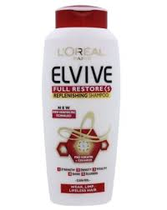](http://www.google.co.uk/url?sa=i&rct=j&q=cheryl+cole+elvive&source=images&cd=&cad=rja&uact=8&docid=uOtqhFMiqv4qsM&tbnid=smFZfKXWkeveIM:&ved=0CAUQjRw&url=http://thegeographyofshampoo.blogspot.com/&ei=51CgU4fhMcfI0wW7ooHADw&bvm=bv.68911936,d.d2k&psig=AFQjCNFYnS_ppEAxHMsn5JTDl8x3IVuLrA&ust=1403101770579916)